**CSS. Box Model.**

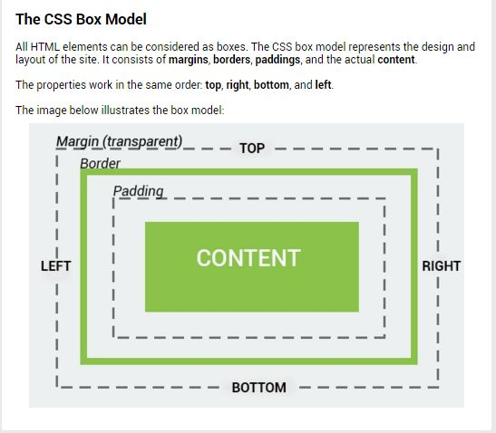

**Total Width of an Element**

When working with boxes, it is important to understand how the total width of an element is calculated.   
For example, the total width of the box with paddings will be the sum of **width** plus **padding left** and **padding right**.

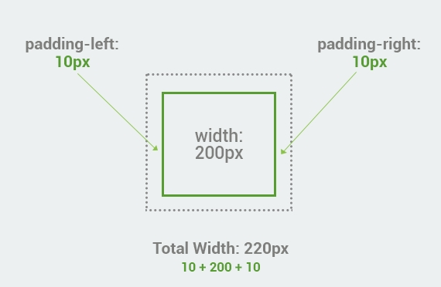

Here is another box with margins, border, and paddings.   
The total width is the sum of **left and right margins**, **left and right borders**, **left and right paddings**, and the **actual width** of the content

.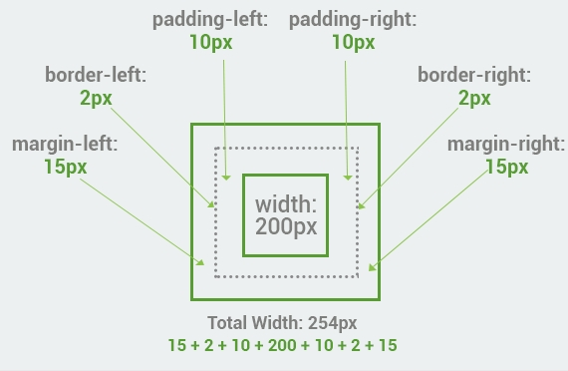

When you set the width and height properties of an element with CSS, you set the width and height of the content area.  
When setting a background-color to a box, it covers the content area, as well as the padding.

**Total Height of an Element**

The total height of an element is also calculates the same way as the width.   
The example below is the same box from the previous lesson with padding, border and margin.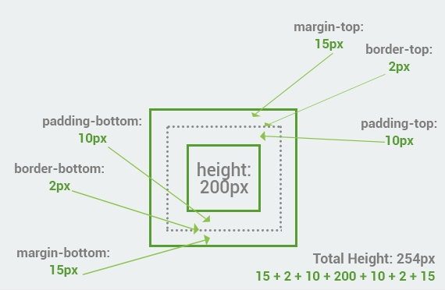

To summarize, Total element height = height + top padding + bottom padding + top border + bottom border + top margin + bottom margin

**The border Property**

The CSS border property allows you to customize the borders of HTML elements.  
In order to add a border to the element, you need to specify the **style**, **size**, and **color** of the border.   
The example below shows how to add a solid green border to the paragraph.  
  
**The HTML:**

<p>This is an example of a solid border.</p>  
**The CSS:**

p {padding: 10px; **border: 5px solid green**;}

**Border Width**

The properties for the border can be set separately. The **border-width** property specifies the width of the border.  
  
**The HTML:**

<p class="first">Border width of this paragraph is set to 2px.</p>  
<p class="second">Border width of this paragraph is set to 5px.</p>  
**The CSS:**

p.first {  
padding: 10px;   
border-style: solid;  
**border-width: 2px;**  
}  
p.second {  
padding: 10px;   
border-style: solid;  
**border-width: 5px;**  
}

**Border Color**

The border color of the element can be defined using a color name, RGB, or Hex values.   
**The HTML:**

<p class="first">Border color has been created using <strong>color name.</strong></p>  
<p class="second">Border color has been created using <strong>Hex values.</strong> </p>  
<p class="third">Border color has been created using <strong>RGB values.</strong> </p>  
**The CSS:**

p.first {  
padding: 10px;  
border-style: solid;  
border-width: 2px;

**border-color: blue;**  
}  
p.second {  
padding: 10px;   
border-style: solid;  
border-width: 2px;  
**border-color: #FF6600;**  
}   
p.third {  
padding: 10px;   
border-style: solid;  
border-width: 2px;  
**border-color: rgb(0, 153, 0);**  
}

None of the border properties will have any effect unless the **border-style** property is set.

**The border-style Property**

The default value of border-style is **none**, which defines no border.   
There are various styles supported for the border-style property: **dotted**, **dashed**, **double**, etc. The example below illustrates the differences between them.   
  
**The HTML:**

<p class="none">This paragraph has no border.</p>  
<p class="dotted">This is a dotted border.</p>  
<p class="dashed">This is a dashed border.</p>  
<p class="double">This is a double border.</p>  
<p class="groove">This is a grooved border.</p>  
<p class="ridge">This is a ridged border.</p>  
<p class="inset">This is an inset border.</p>  
<p class="outset">This is an outset border.</p>  
<p class="hidden">This is a hidden border.</p>  
**The CSS:**

p.none {border-style: none;}

p.dotted {border-style: dotted; color:red;}

p.dashed {border-style: dashed;color:blue;}

p.double {border-style: double;color:green;}

p.groove {border-style: groove;color:yellow;}

p.ridge {border-style: ridge;color:orange;}

p.inset {border-style: inset;color:black;}

p.outset {border-style: outset;color:purple;}

p.hidden {border-style: hidden;color:silver;}

In CSS, it is possible to specify different borders for different sides, using the following properties:

border-top-style,

border-right-style,

border-bottom-style,

border-left-style (for the corresponding sides).